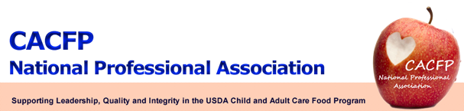

November 2012 Message of the Month

FNS Update

- Memo: Streamlining SFA Participation in CACFP At-Risk Afterschool Program anticipated release is December 2012.

- Proposed CACFP Meal Patterns: The CACFP Meal Pattern proposed rule is in clearance; no date for release. Meetings are being conducted to set priorities and time lines now that the election is over.

FRAC Update

- Geri Henchy is attending hunger meetings and the atmosphere seems favorable for the Child Nutrition Programs (CNP).There is a sense of bi-partisan support for the CNP. USDA is taking stock and moving forward on the proposed rule for competitive foods and CACFP meal patterns initiatives. Pressure is still on the SNAP to reduce funding and possible block grants.

- 2013 National Anti-Hunger Conference will be held March 3-5, 2013 at the Capital Hilton in Washington, DC.

Workgroup Update

- USDA’s CACFP Technical Assistance Workgroup - The Workgroup met on October 24, 2012 and discussed contracting with a research organization to conduct needs assessment on the types of technical assistance to best benefit providers. A request for proposal (RFP) is currently being developed for competitive bids to select a research team. The Workgroup also discussed a Provider Wellness Handbook that would include tip sheets, best practices, resources, and outreach materials. The Workgroup utilized evidence based resources such as North Carolina NAPSAC and States that currently have one of the USDA CACFP child care wellness grants working on voluntary awards for CACFP providers such as New York’s Eat Well Play Hard, Washington D.C. I am Healthy; I am Happy, and Missouri’s Eat Smart Child Care.

- USDA’s Paperwork Reduction Workgroup – In order to provide administrative relief to state agencies, institutions and facilities, USDA created this workgroup to review and assess paperwork in CACFP and make recommendations for reductions. A survey for sponsors and independent centers will soon be released to capture information that identifies areas that seem to create a paperwork burden and to attempt to determine the cause of those burdens. The Workgroup will use this information to make recommendations to submit to Congress in a report due by June 2014.

- Sponsor’s Consortium Workgroup – The Workgroup continues its efforts to communicate and provide support to individuals, State Agencies, and sponsors on how to submit written comments on the upcoming proposed meal pattern changes for the CACFP.

Call for Wellness Initiatives/Activities

- Submit to your Regional Representative any Wellness Initiatives and/or Activities you have incorporated into your CACFP. Provide your state’s website link to share these valuable resources and best practices. The information will be collected and posted on the CACFP NPA website. Your Regional Representative looks forward to your input. Please hit “Reply” to this email to submit your information.

Website

Continue to check the website at http://www.cacfpnpa.org for the most up-to-date information and minutes from the monthly board meetings.

